

**Batch: B-1 Roll No.: 16010422234 Name: Chandana Ramesh Galgali**

**Experiment No.: 09**

**Aim: Write an 8086 assembly program to input a string and reverse it.**

**___________________________________________________________________________**

**Resources needed:** DOSBOX, TASM

**___________________________________________________________________________**

**Theory:**

String manipulation is one of the most common operations in programming (in any language). Some of the most common string functions are strcpy, strlen, strcat, strrev, strchr, strstr, strtok etc.

In this program we first input a string using the DOS function AH=0AH, INT 21H.

The string buffer which stores the incoming string has the following format:-

1. The first byte indicates the maximum characters which the user is allowed to enter. If more characters are entered they are simply ignored.
2. The second character is filled with the actual number of characters entered by the user including the enter key (last character is 0x0d).
3. The remaining space holds the actual input string.

We then check for an empty string; if so display an error message and exit.

Otherwise we reverse the string one character at a time and then display both the original and the reversed string.

**__________________________________________________________________________**

; ----------------------------------------

; Program: Input a string and reverse it.

; FileName: expt9.asm

; ----------------------------------------

dispstr macro strname

mov ah, 09h

mov dx, offset strname

int 21h

endm

crlf macro

mov dl, 0ah

mov ah, 02h

int 21h

mov dl, 0dh

mov ah, 02h

int 21h

endm

.model small

.stack 100h

.data

buff db 20 ;MAX NUMBER OF CHARACTERS ALLOWED (18).

db ? ;NUMBER OF CHARACTERS ENTERED BY USER.

str1 db 18 dup(0) ;CHARACTERS ENTERED BY USER(17)+0x0d

rbuff db 18 dup(0)

msg1 db "Orig String:",'$'

msg2 db "Rev String:",'$'

msg3 db "Empty String",'$'

.code

main:

mov ax, @data

mov ds, ax

mov es, ax

;CAPTURE STRING FROM KEYBOARD.

mov ah, 0Ah ;SERVICE TO CAPTURE STRING FROM KEYBOARD.

mov dx, offset buff

int 21h

;CHANGE CHR(13) BY '$'.

mov si, offset buff + 1 ;NUMBER OF CHARACTERS ENTERED.

mov cl, [ si ] ;MOVE LENGTH TO CL.

mov ch, 0 ;CLEAR CH TO USE CX.

inc cx ;TO REACH CHR(13).

add si, cx ;NOW SI POINTS TO CHR(13).

mov al, '$'

mov [ si ], al ;REPLACE CHR(13) BY '$'.

crlf

do_reverse:

mov si, offset buff + 1 ;NUMBER OF CHARACTERS ENTERED.

mov cl, [ si ] ;MOVE LENGTH TO CL.

mov ch, 0 ;CLEAR CH TO USE CX.

cmp cx,0 ; Check for empty string

je empty

add si, cx ; Make si point to end of string

mov di, offset rbuff ; Make di point to start of reverse string

nxtchr:

mov al, [si] ; Read next character from si from right

mov [di], al ; Store in rbuff

dec si ; update pointers

inc di

loop nxtchr ; loop decrements cx and checks for 0,

; If not 0 repeat the loop

mov al, '$' ; Add '$' to indicate end of string

mov [di], al ;

; Now display both strings

dispstr msg1 ; Display original string

dispstr str1

crlf

dispstr msg2 ; Display reversed string

dispstr rbuff

jmp over

empty:

dispstr msg3

crlf

over: mov ah, 4ch ; program over, call exit() function

int 21h

end

**_________________________________________________________________________**

**Procedure**:

1. Download and install DOSBox and TASM in C drive
2. Type the programs given in this file and save them as .asm files.
3. Run DosBox
4. In the DosBox window, compile and run the program:

> tasm /l expt8.asm

> tlink expt8.obj

> expt8.exe

1. Verify the desired output

**___________________________________________________________________________**

**Observations and Results:**

Both the programs should display the desired outputs in the DOSBOX window.

Paste the snapshots here.

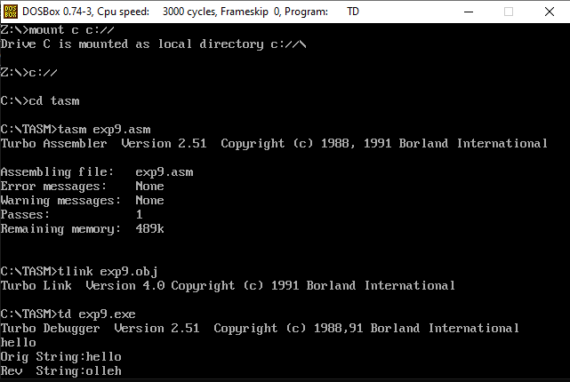

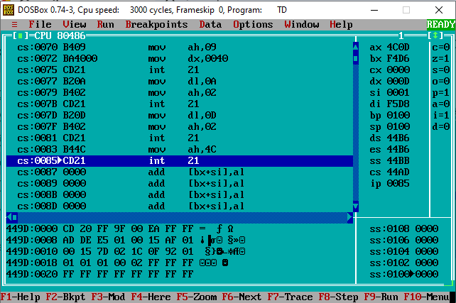

**___________________________________________________________________________**

**Outcomes: Understand the fundamental concepts of microprocessors.**

**Conclusion:**

In conclusion, the experiment aimed to write an 8086 assembly program that would input a string and reverse it. The program was successfully implemented, achieving the desired objective.

**___________________________________________________________________________**

**Grade: AA / AB / BB / BC / CC / CD /DD**

**Signature of faculty in-charge with date**

**___________________________________________________________________________**

**References:**

**Books/ Journals/ Websites:**

1. “Microprocessors and Interfacing”, by Douglas Hall Tata McGraw Hill 3rd edition.